**Compiler Design Lab (CS 306L)**

**C.Ganesh T.V.M Sai**

**AP19110010342**

**CSE - C**

**Week 1: Implementation of Language recognizer**

**Week 1 Programs**

1. Implementation of Language recognizer for set of all strings over input alphabet ∑={a,b} containing even number of a’s and even number of b’s.

2. Implementation of Language recognizer for set of all strings ending with two symbols of same type.

**Program 1:**

Implement a language recogniser which accepts set of all strings over the alphabet ∑={a,b} containing an even number of a’s and an even number of b’s.

**Description:**

The acceptable strings of the language are ε(Null string), aa, bb, abba, babbab etc. Deterministic Finite Automata for the given language is given below:

. 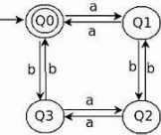

DFA M=(Q,∑,δ,Q0,F) Where Q=Set of all states ={Q0,Q1,Q2,Q3} ∑=Input Alphabet={a,b},

Start state is Q0

F=Set of all final States={ Q0}

And the transitions are defined in the transition diagram

**Algorithm: Language recognizer**

**Input:**

*input* //input string

**Output:**

Algorithm prints a message

“String accepted”: If the input is acceptable by the language,

“String not accepted” otherwise,

“Invalid token”: If the input string contains symbols other than input alphabet.

**Method:**

state=0 //initial state

i=0

while((current=input[i++])!='\0'){

switch(state)

case 0: if(current=='a') state=1;

else if(current=='b') state=2;

else

Print "Invalid token" ; exit;

case 1: if(current=='a') state=0;

else if(current=='b') state=3;

else

Print "Invalid token" ; exit;

case 2: if(current=='a') state=3;

else if(current=='b') state=0;

else

Print "Invalid token" ; exit;

case 3: if(current=='a') state=2;

else if(current=='b') state=1;

else

Print "Invalid token" ; exit;

end switch

end while

//Print output

if(state==0)

Print ”String accepted”

else

Print ”String not accepted”

**Code:**

#include<stdio.h>

void main()

{

int state=0,i=0;

char token,input[20];

printf("Enter input string \t :");

scanf("%s",input);

//printf("Given string is : %s");

while((token=input[i++])!='\0')

{

// printf("current token : %c \n",token);

switch(state)

{

case 0: if(token=='a')

state=1;

else if(token=='b')

state=2;

else

{

printf("Invalid token");

exit(0);

}

break;

case 1: if(token=='a')

state=0;

else if(token=='b')

state=3;

else

{

printf("Invalid token");

exit(0);

}

break;

case 2: if(token=='a')

state=3;

else if(token=='b')

state=0;

else

{

printf("Invalid token");

exit(0);

}

break;

case 3: if(token=='a')

state=2;

else if(token=='b')

state=1;

else

{

printf("Invalid token");

exit(0);

}

break;

}

// printf("state = %d ",state);

}

if(state==0)

printf("\n\nString accepted\n\n");

else

printf("\n\nString not accepted\n\n");

}

**Test cases:**

|  |  |
| --- | --- |
| **Input** | **Expected Output** |
| aabb | String accepted |
| abab | String accepted |
| aaabb | String not accepted |
| aaa | String not accepted |
| abcd | Invalid token |

**Program 2:** Implementation of Language recognizer for set of all strings ending with two symbols of the same type.

**Description:** Any string where the last two symbols were the same is acceptable. The strings are like aa, aaa, baa, bababb, etc. Deterministic Finite Automata for the given language is given below :

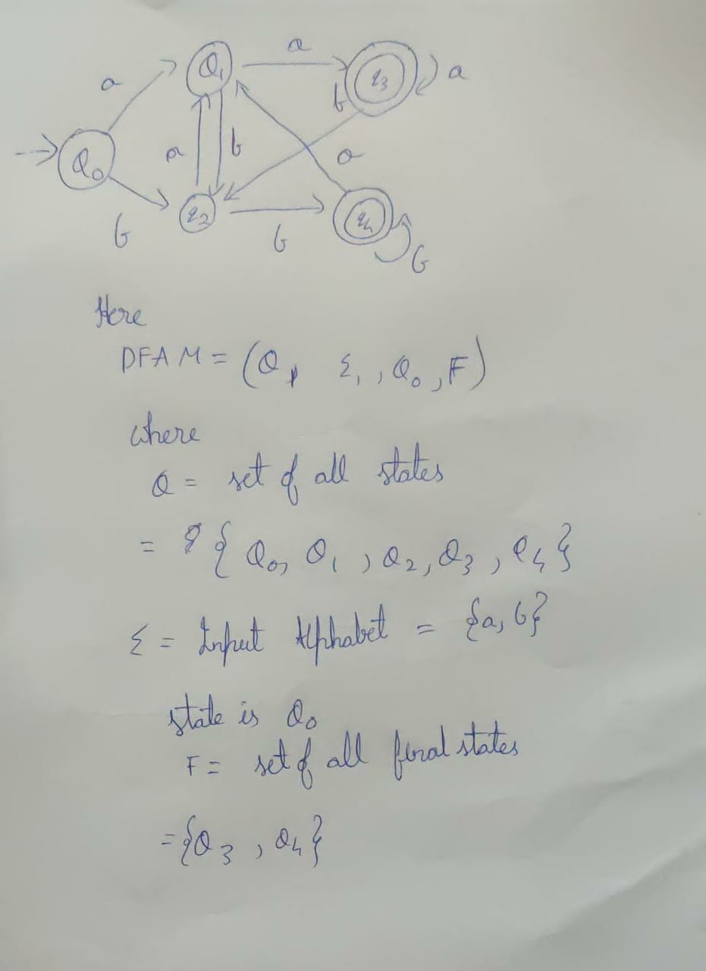

**Algorithm**: Language recognizer

**Input:** input //input string

**Output:** Algorithm prints a message:

“String accepted”: If the input is acceptable by the language,

“String not accepted” otherwise,

“Invalid token”: If the input string contains symbols other than the input alphabet.

**Code:**

#include <stdio.h>

int main(void)

{

char s[1000];

scanf("%s",s);

int state = 1;

for(int i=0; s[i]!='\0'; i++)

{

switch(s[i])

{

case 'a':

if(state==1)

state = 2;

else if(state==2)

state=3;

else if(state==4)

state =2 ;

else if(state ==5)

state = 2;

break;

case 'b' :

if(state==1)

state = 4;

else if(state == 4)

state = 5;

else if(state == 2)

state = 4;

else if(state ==3)

state = 4;

break;

default:

printf("Invalid Token");

exit(0);

}

}

if(state==3 || state ==5)

printf("accepted ");

else

printf("not accepted");

printf("\n");

return 0;

}

|  |  |
| --- | --- |
| **Test Cases** | **Output** |
| abaa | accepted |
| abaaba | Not accepted |
| aabb | accepted |
| abbab | Not accepted |